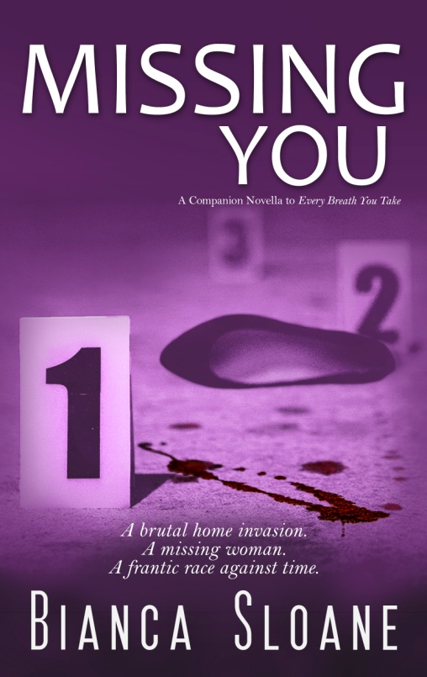

When Jason Hudson comes home on Friday night, he’s ready for a cold beer, leftover Chinese and a quiet weekend. Instead, he walks into a nightmare when he’s viciously stabbed and left for dead.

Chicago Police Detective Bill Hanson catches the case and it’s clear this crime is far from random; nothing is stolen and the number of stab wounds all point to one inescapable fact.

It’s personal.

And where is Jason’s fiancée, Natalie?

**MISSING YOU, A COMPANION NOVELLA TO EVERY BREATH YOU TAKE, will take you on an emotional ride through the secrets of the past to solve the mysteries of the present.**

**EVERY BREATH YOU TAKE is a dark and disturbing thriller that will stay with you long after the last page. . .**

**MISSING YOU, A COMPANION NOVELLA TO EVERY BREATH YOU TAKE,**

**the latest novel of suspense by Bianca Sloane, is due for release**

**December 2015**

**Word Count:** 41,723

**Genre:** Mystery/Suspense

**Formats:** eBook (Amazon.com)

Paperback (CreateSpace.com and Amazon.com)

*“Sloane has a knack for drawing readers in.”*

**-OOSA Online Book Club**

**The Books of Bianca Sloane:**

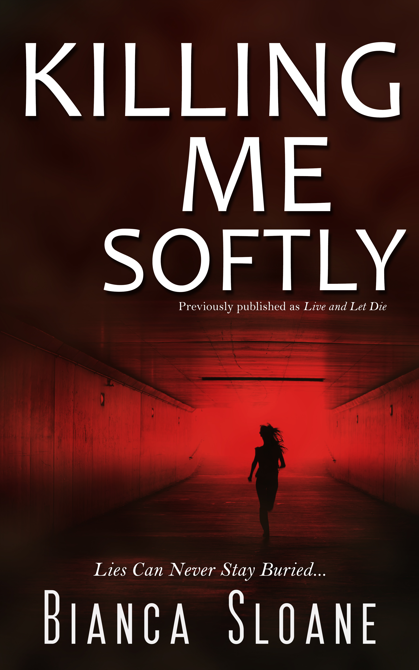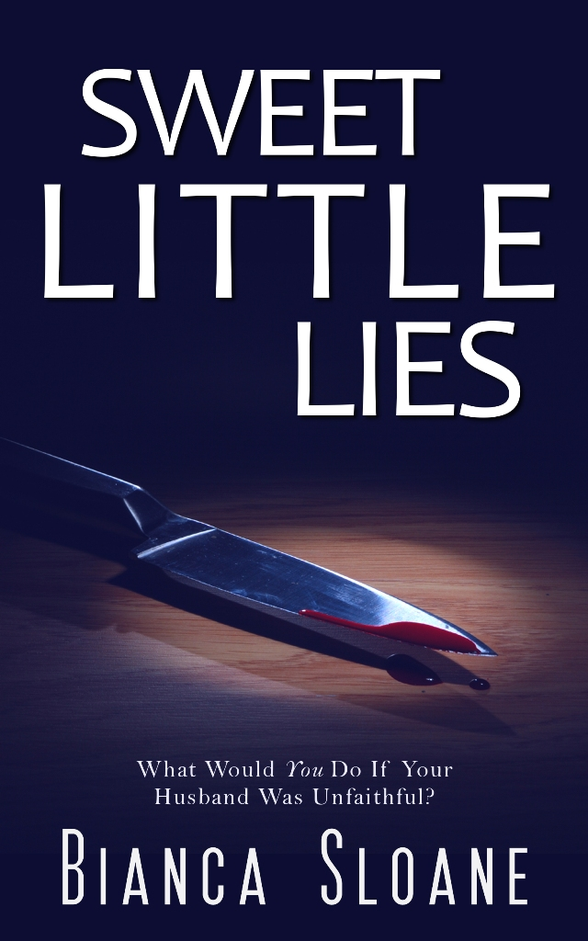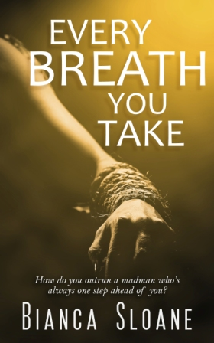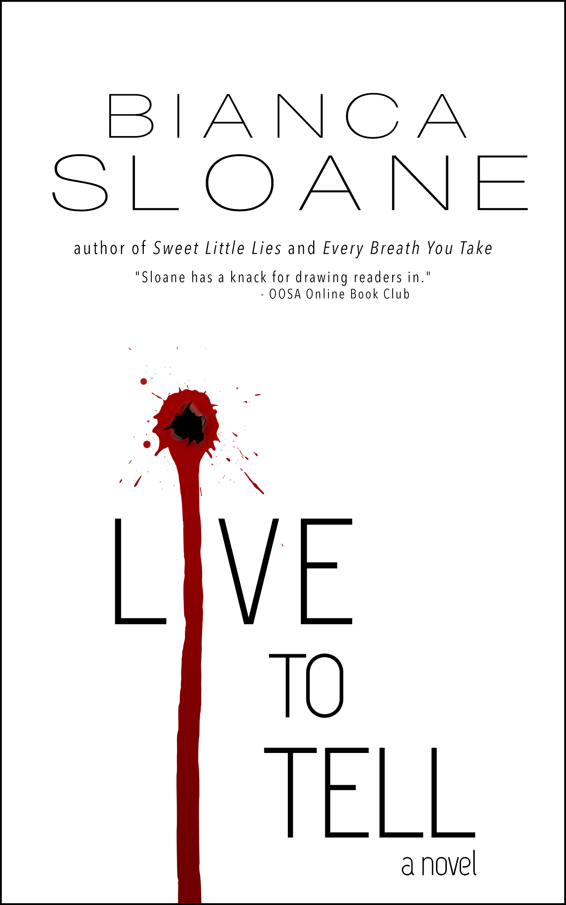

**Contact Details:**

Email: [Bianca@BiancaSloane.com](mailto:Bianca@BiancaSloane.com) * Website: [www.biancasloane.com](http://www.biancasloane.com) * Blog: [biancasloane.blogspot.com/](http://biancasloane.blogspot.com/) * Facebook: BiancaSloaneSuspenseWriter * Twitter: @BiancaSloane * Pinterest: [www.pinterest.com/biancasloane](http://www.pinterest.com/biancasloane) * Goodreads:[goodreads.com/author/show/6871899.Bianca_Sloane](http://www.goodreads.com/author/show/6871899.Bianca_Sloane)

A brutal home invasion leaves a man fighting for his life – and police on the hunt for his missing fiancée. . .

**About the Author**

Bianca Sloane is the author of the suspense novels, "Killing Me Softly" (previously published as "Live and Let Die") chosen as "Thriller of the Month" (May 2013) by e-thriller.com and a "2013 Top Read" by OOSA Online Book Club and "Sweet Little Lies," “Every Breath You Take,” and “Missing You.” When she's not writing, she's watching Bravo TV, Investigation Discovery, reading or cooking. Sloane resides in Chicago.

**Missing You, a companion novella to Every Breath You Take**

by

Bianca Sloane